



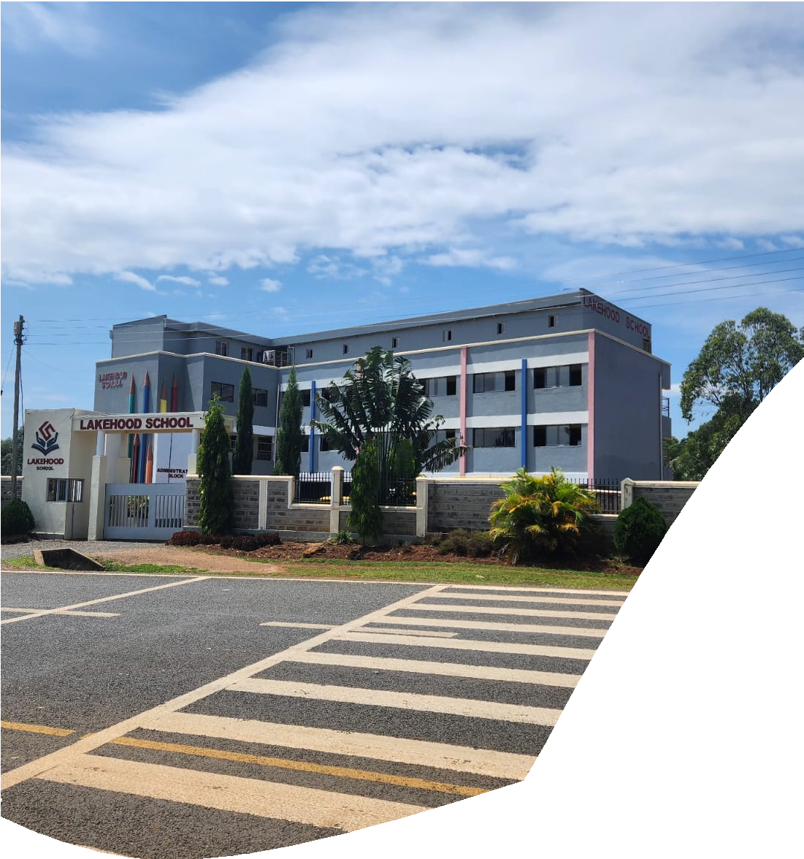





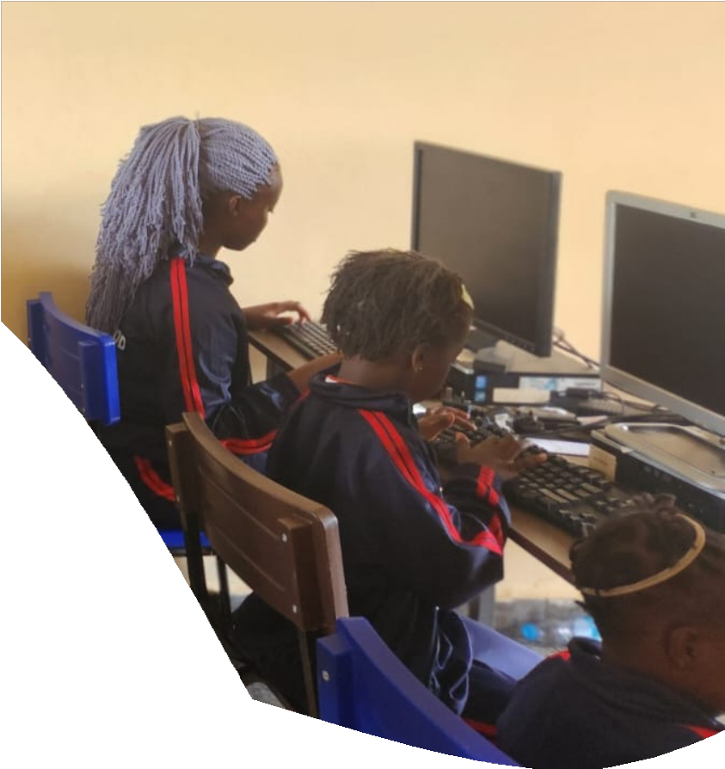

n

LAKEHOOD SCHOOL
BOARDING FEE STRUCTURE
2026 ACADEMIC YEAR

Unearthing Talents

ZONE(S) | TRANSPORTATION ROUTES | CHARGES
ZONE A-1 | Rongo Town | 6500
ZONE A-2 | Riosiri, Nyarach, Sare, Rakwaro, Kanyawanga, Kangeso, Kanga | 9000
ZONE B | Nyabigege, Nyaburu, Ranen | 10000
ZONE C | Tabaka, Awendo, Nyamarambe | 12000
ZONE D | Suneka, Opapo | 12000
ZONE E | Kisii | 14000
MIDDLE AND JUNIOR SCHOOL FEE STRUCTURE

PAYMENT DETAILS (KES)
METHOD | INSTRUCTIONS | PROOF
Bank Deposit | Bank Name: KENYA COMMERCIAL BANK (KCB)  Account No: 1 2 8 7 7 5 8 1 4 2  Account Name: LAKEHOOD SCHOOL | Bankslip
M-Pesa | Paybill No: 4 0 9 8 7 1 1  Account No: CHILD’S NAME & GRADE | Transaction Message Send to: 0746614744
NOTE: STRICTLY NO CASH PAYMENT
The Lakehood School opened its doors in July 2021 to offer the Competency-Based Curriculum (CBC). The school prides itself on excellent infrastructure, experienced and tested staff to give quality education at Pre-primary, Primary and Junior School.

FEE STRUCTURE (KES)
GRADE(S) | TERM 1 | TERM 2 | TERM 3 | BOARDING FEES
Play Group | 15800 | 15800 | 12400
PP1 and PP2 | 16800 | 16800 | 13400
Grades 1 and 2 | 20800 | 20800 | 15400
Grade 3 | 22800 | 22800 | 16400
Grades 4 | 22800 | 22800 | 16400 | 29000
Grade 5 | 24800 | 24800 | 18,400 | 29000
Grade 6 | 25,800 | 25,800 | 20,800 | 29000
Grade 7, 8 and 9 | 30,800 | 30,800 | 20,400 | 29000
Fees include tuition, exercise books, school diary, Computer classes, French classes, and health care, which covers basic first aid at school and emergency transport services.

For any payment inquiries, please contact the school via: 0742455723 or 0746614744 Email: info@lakehoodschool.sc.ke

A 15% discount on school fees is only available to the younger sibling of a child enrolled into the school, provided that the fees are paid in FULL on or before the opening date of the term
Fees once paid are non-refundable nor transferable
All amounts which remain outstanding after the term commences will be charged accumulative administrative fee on late payment at 3% per month of the outstanding amount.
Fees and other charges in the fee structure do not include ancillary charges such as activity fees, trip fee, co-curricular activities and other incidental charges
​A full term’s notice in writing is required and submitted on or before the opening day for withdrawals, otherwise a FULL TERM’S FEE WILL BE CHARGED.
A payment plan can be arranged with the admissions office.
Transport services are only available from designated picking/dropping points. Door-to-door services are not provided.
SUMMARY OF TERMS AND CONDITIONS
OTHER CHARGES (KES)
NO. | ITEM | CHARGES
1. | Interview fee (Non-refundable) | 1,000/=
2. | Admission fee (Non-refundable) | 3,000/=
3. | Caution money (refundable upon adequate notice and clearance procedures) | 5,000/=
4. | Administrative levy (Annually) | 2,000/=
5. | Boarding fee (Accommodation and meals) | 29000/= Primary & JSS
6. | Swimming (Optional, per term) | 2,000/=
7. | Uniform (available in school) | Depends on the LEVEL
8. | Music (Optional) | 3,000/= Per Term
9. | Taekwondo (Optional) | 2,000/= Per Term

The boarding charges are as indicated, Ksh 29,000 per term.

