



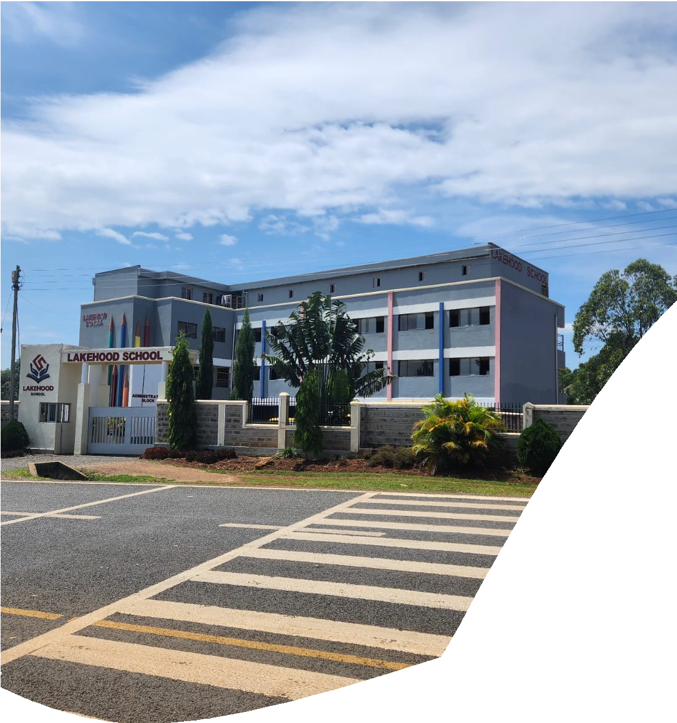





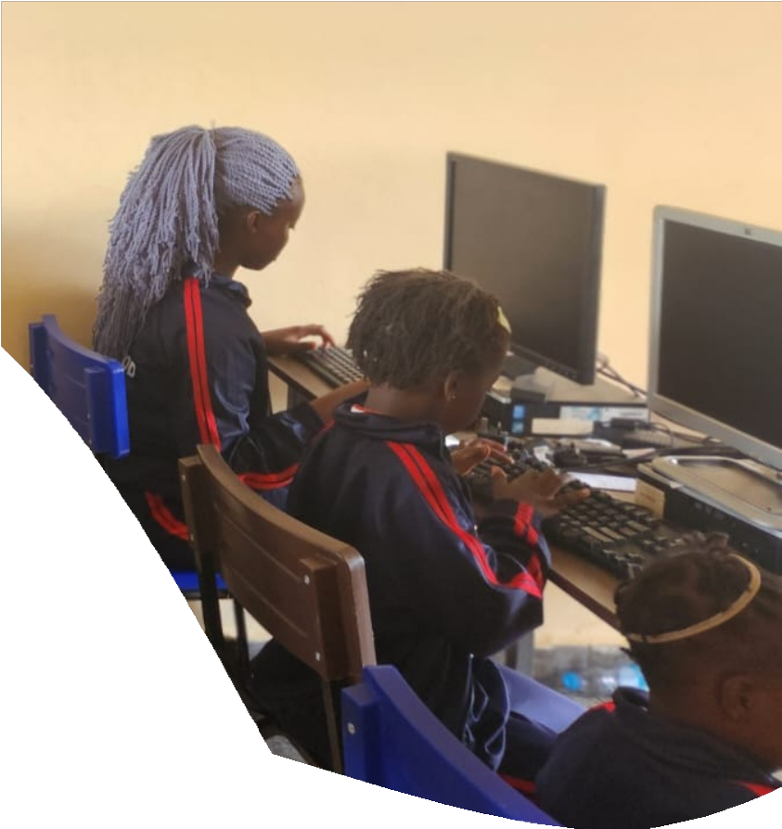
n

LAKEHOOD SCHOOL
BOARDING FEE STRUCTURE
2026 ACADEMIC YEAR

Unearthing Talents

MIDDLE AND JUNIOR SCHOOL FEE STRUCTURE

The Lakehood School opened its doors in July 2021 to offer the Competency Based Curriculum (CBC). The school prides itself in excellent infrastructure experienced and tested staff to give quality education at Pre-primary, Primary and Junior School.
PAYMENT DETAILS (KES)
METHOD | INSTRUCTIONS | PROOF
Bank Deposit | Bank Name : KENYA COMMERCIAL BANK (KCB)  Account No: 1 2 8 7 7 5 8 1 4 2  Account Name: LAKEHOOD SCHOOL | Bankslip
M-Pesa | Paybill No : 4 0 9 8 7 1 1  Account No: CHILD’S NAME & GRADE | Transaction Message Send to: 0746614744
NOTE: STRICTLY NO CASH PAYMENT

FEE STRUCTURE (KES)
GRADE(S) | TERM 1 | TERM 2 | TERM 3 | BOARDING FEES
Grades 4 | 22800 | 22800 | 16400 | 29000
Grade 5 | 24800 | 24800 | 18,400 | 29000
Grade 6 | 25,800 | 25,800 | 20,800 | 29000
Grade 7, 8 and 9 | 30,800 | 30,800 | 20,400 | 29000
Fees include tuition, exercise books, school diary, Computer classes, French Classes and health care which covers basic first aid at school and emergency transport services.

For any payment inquiries, please contact the school via: 0742455723 or 0746614744 Email: info@lakehoodschool.sc.ke
- A 15% discount on school fees is only available to the younger sibling of a child enrolled into the school, provided that the fees are paid in FULL on or before the opening date of the term
- Fees once paid are non-refundable nor transferable
- All amounts which remain outstanding after the term commences will be charged accumulative administrative fee on late payment at 3% per month of the outstanding amount.
- Fees and other charges in the fee structure do not include ancillary charges such as activity fees, trip fee, co-curricular activities and other incidental charges
- ​A full term’s notice in writing is required and submitted on or before the opening day for withdrawals, otherwise a FULL TERM’S FEE WILL BE CHARGED.
- A payment plan can be arranged with the admissions office.
SUMMARY OF TERMS AND CONDITIONS

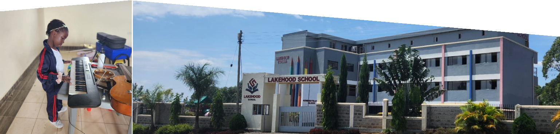
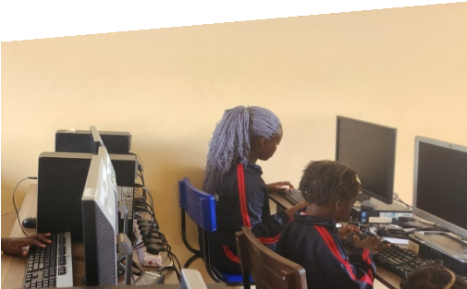
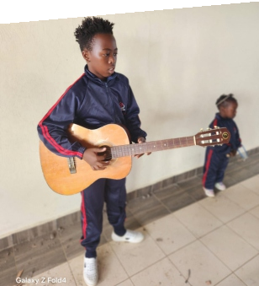
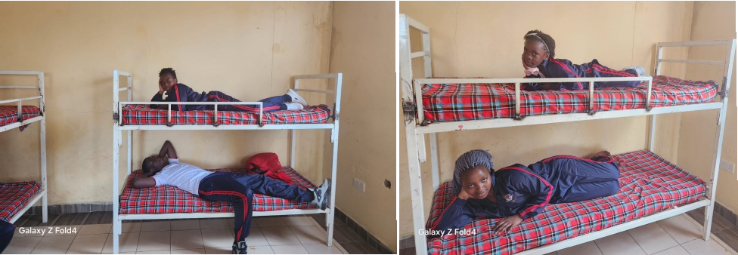
OTHER CHARGES (KES)
NO. | ITEM | CHARGES
1. | Interview fee (Non-refundable) | 1,000/=
2. | Admission fee (Non-refundable) | 3,000/=
3. | Caution money (refundable upon adequate notice and clearance procedures) | 5,000/=
4. | Administrative levy (Annually) | 2,000/=
5. | Boarding fee (Accommodation and meals) | 29000/= Primary & JSS
6. | Swimming (Optional, per term) | 2,000/=
7. | Uniform (available in school) | Depends on the LEVEL
8. | Music (Optional) | 3,000/= Per Term
9. | Taekwondo (Optional) | 2,000/= Per Term

